DISSONANCE
  - First-Arc Reader Sample
Manuel A. Domínguez
2026-07-25
Table of Contents

DISSONANCE: First-Arc Teaser
A reader sample from the First Edition
By Manuel A. Domínguez

This sample contains the canonical Prologue and Chapter 1 of DISSONANCE, the opening movement of Act I, “The Wrong Hum.” The narrative excerpt below is reproduced from the current First Edition canonical manuscript. It does not replace the canonical manuscript or the consumer distribution package.
Source: First Edition canonical, DIS-FE-20260716-0001
Excerpt boundary: Prologue through Chapter 1
Reader promise: A household in Year 19 confronts a changed carrier, ration shortages, and a record the Board cannot absorb.
Copyright © 2026 Manuel A. Domínguez. All rights reserved. Shared for reader preview only. No reproduction or redistribution without permission, except for brief quotations in reviews.
AI use and verification disclosure: AI tools were used in the research and development of this sample. Its cover artwork was generated with OpenAI Image 2, then selected and produced for this edition by Manuel A. Domínguez. The excerpt was checked against the current canonical manuscript, including source integrity, spoiler control, and production-format validation. These editorial safeguards support accuracy and consistency; they are not scientific, medical, or cultural certification.
Cover source: DISSONANCE_Ebook_Cover_Canon.png is the approved front art extracted from the First Edition paperback sleeve. Its title and byline remain intact in the sample export.

Prologue
MOVEMENT 01 // ACT I // UNIT 01
The Wrong Hum
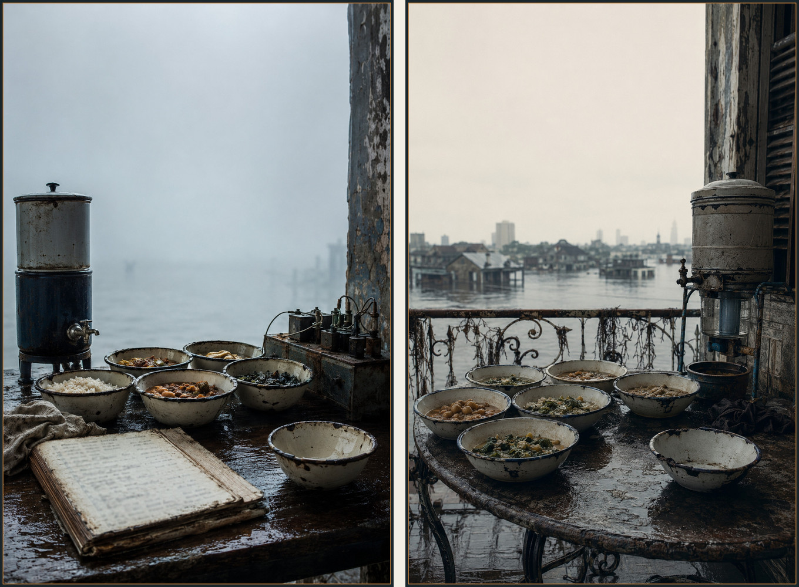
Record catalogued: NO-NNO-07-001.
WARD 7, THE ANVIL. Before dawn, Day 1, Year 19.
Yvonne set the bowls out before she lit the stove. Tin first, then the blue cloth over the bowl that had no mouth left to answer for it. Behind the house, roof water moved through gravel and reed roots into two cracked drums. Yvonne cleared a snail shell from the screen, smelled the water, and set the shell aside for Junie. The filter bought washing water. The canal remained unsafe.
The shrine glass stood beside the cold burner. Yvonne touched its rim. Water rose above the lip, held for a breath, then fell flat. She filled the glass again from the covered barrel and watched it rise a second time.
She checked the rice sack. It would feed six people if she thinned her own bowl. She marked the barrel level and the changed hum on yesterday’s ward receipt, wrapped the paper in oilcloth, and hid it beneath the counter. Solène would need it before the first grain sack opened.
The house shuddered. Yvonne covered the blue bowl with her palm.
“Stay,” she said.
The charcoal in the brazier had gone soft at the edges. Yvonne broke the largest piece with the back of a spoon and sifted the dust into the next day’s fuel tin. The kitchen could burn through a quarter of a tin before breakfast if the draft held east. She set a flat stone against the lower vent and listened for the change in the flame. The stone had belonged to a neighbor who traded it for three days of roof water during the last high tide. Objects in the Anvil carried their old bargains.
Across the lane, a shutter opened and closed. Mrs. Baptiste’s grandson had been waiting for a runner with his medication since the night ferry stopped. The boy’s breathing made a thin, dry rasp that reached the kitchen only when the wind dropped. Yvonne poured a cup from the covered barrel, added a measured pinch of salt, and carried it to the gate. She did not call the mixture treatment. She gave the boy water while his aunt checked the empty road.
The ferry runner arrived forty minutes later with the packet wrapped in waxed cloth. The Board seal was broken. One ampoule had cracked. Yvonne took the unbroken dose, checked its label against the family’s last clinic card, and wrote the breakage on the delivery receipt. The aunt offered a ration tab. Yvonne pushed it back.
“Keep it for supper, dale,” she said. “The receipt is enough.”
Back in the kitchen, she climbed the ladder to the roof filter. The screen held reed fluff, a dead beetle, and a line of black grit that had not been there the day before. She rinsed the screen into a basin marked wash only, weighed the clear water, and marked the loss beside the barrel level. The filter could give the household two more days of washing if no hard rain followed. Drinking water would still come from the covered drum and the neighbor’s kindness.
Yvonne set the empty basin below the gutter. She knew how much work a clean roof cost: one person to scrape, one to hold the ladder, one to watch the first flush, and a child to remember which mark on the wall belonged to which storm. She wrote the names on the receipt before she folded it. A record that named only the water taught the wrong lesson about who had kept it usable.
When Solène woke, Yvonne had already banked the stove and wrapped the medication receipt in oilcloth. She did not tell Solène about the broken ampoule until the ledger was open. The omission was not secrecy. It was triage: food and the changed hum first, a neighbor’s private loss when the house had enough hands to carry it.
Solène came into the kitchen with one sock inside out and her hair tied in the cord she used for bundles of forms. She saw the covered bowl, the receipt, and the cup Yvonne had taken to the gate. Yvonne put the receipt between them. The paper had softened where rain had reached the fold.
“The runner broke one,” Yvonne said.
Solène read the label twice. “The boy got the other.”
“He got water first. The aunt found a ferry worker who could keep the dose cold.”
“And the replacement?”
“The receipt asks for one. It does not promise one.”
Solène copied the ampoule number into the private household ledger. She left the neighbor’s name out of the public page and wrote the delivery route in a separate line. The route went through a ferry worker who had asked not to appear in a Board list. A fact could remain useful without becoming a handle.
Junie came from the sleeping room carrying the blue cloth. She had folded it into four squares and held it against her chest. The empty bowl sat on the counter beside the flour tin.
“Does it mean someone is coming back?” Junie asked.
Yvonne took the cloth and shook it once. “It means we keep a place for what we cannot settle.”
“That is not an answer.”
“It is the answer I have.”
Solène watched Junie look at the bowl. The child’s face did not ask for a lesson about water, sound, or the names Yvonne kept. It asked whether the house had made a promise. Yvonne placed the cloth back on its hook and let the question stay particular.
Marcel called from below that the relay had made the wash pump start late. His voice rose through the floorboards with a dry irritation that made the kitchen glass tremble. Solène took the pantry book to the stair. Yvonne stopped her with two fingers at the wrist.
“Eat first.”
“The distribution center opens in an hour.”
“Then carry the food with you.”
Yvonne divided the rice into six bowls and set one aside for the neighbor’s boy. The household did not call the share charity. It called it a delivery with a receipt still owed. Junie marked the barrel level while Solène wrote the names of the people who would help scrape the roof after the next rain. The work started before anyone had agreed that the morning was safe.
At the back door, Yvonne tested the latch and listened to the lane. A patrol bell sounded once near the canal. Nobody in the kitchen moved toward it. Solène tied the private ledger under her shirt and put the public forms in a canvas sleeve. The two records left the table together. They would not take the same route.
Junie followed her to the gate. Yvonne handed the child the receipt for the neighbor’s medication and asked her to keep the oilcloth dry. Junie held the packet with both hands. The instruction made her a carrier of paper, not a witness to a ritual. Yvonne stayed at the doorway until the two girls turned the corner, then returned to the filter with the empty basin.
The lane quieted after the girls left. Yvonne rinsed the basin, scraped the dead beetle from the filter screen, and poured the first water onto the compost trench. She kept the clean portion in the wash drum and marked the level with a strip of charcoal. The work belonged to the house. It did not stand for the ward.
At the gate, Mrs. Baptiste’s grandson called for her. His aunt had counted the ampoule again and found the label readable. The boy’s breathing still rasped. Yvonne asked whether the clinic should see him. The aunt chose to wait for the ferry worker who knew the route and could keep the dose cold. Yvonne accepted the answer and added a follow-up time to the private receipt.
Junie returned before the stove cooled. The oilcloth was dry. She had not opened the packet. Yvonne asked what she had seen on the walk. Junie named a broken shutter and a patrol bell. She did not name the houses behind them. Yvonne wrote the two street facts on the public route card and left the doors out.
Solène came back for the receipt and found Yvonne measuring charcoal dust. She asked whether the blue bowl needed a new cloth. Yvonne said the cloth could be washed and used again. Solène washed it in the basin marked for household water. The empty bowl stayed covered while the ordinary work continued.
Before noon, the neighbor’s aunt sent a child to return the ration tab Yvonne had refused. Yvonne returned it a second time and wrote tab retained by family on the private copy. The note kept the exchange from becoming a debt. The Anvil’s morning had a broken ampoule, a changed hum, and a filter that needed clearing again after supper.
The filter needed clearing sooner. A gust came off the canal and pushed a skin of gray foam across the gutter. Yvonne heard it strike the screen and climbed before Solène could stop her. The ladder shifted on the wet brick. Solène held the side rail while Junie stood below with the wash basin, watching the first runoff darken the leaves in the compost trench.
“Do not catch that,” Yvonne called.
Junie moved the basin anyway. Solène put a hand over the rim. The basin was for the clean portion, and the first flush carried whatever the roof had gathered. Junie let go. The water struck the trench and made a shallow brown fan through the mulch.
Yvonne scraped the screen with the spoon she used for charcoal. A thread of packing fiber came loose, then a small metal washer. She placed both on the roof ledge. The washer had a stamped number and a sharp edge. It could have come from the relay dock or from a gutter repair. She did not assign it a story. She called down for the private ledger.
Solène brought the ledger up in its oilcloth and wrote the time, the wind, and the objects. Yvonne checked the roof seam with two fingers. The seam leaked at the corner where the neighbor’s old stone had been set as a brace. The stone had shifted. Fixing it required a second person on the roof and a length of dry cord. The house had one length. Marcel had used the other on the relay.
Junie fetched a cord from the sleeping room and laid it on the kitchen table. She asked whether the washer belonged in the public record. Solène asked what the record would let another person do. Junie looked at the object and said, “Find the leak.”
“Then the public card gets the leak and the time,” Solène said. “The washer stays here until somebody can say where it came from.”
Yvonne replaced the blue cloth over the bowl before she returned to the roof. She washed the cloth in the basin marked household water, wrung it by hand, and hung it where the steam could reach it. The action belonged to this kitchen and to the people who kept this place supplied. It did not announce a rule for a neighbor’s house.
Marcel came up the stairs with a relay bracket under his arm. He saw the wet roof seam and set the bracket down. The repair could wait ten minutes. The household could not keep catching dirty runoff. He held the ladder while Yvonne tied the cord. Solène read the marks aloud. Junie kept the public card dry beneath her shirt.
When the clean portion ran, Yvonne poured it into the wash drum and measured the loss. The house had lost a day’s margin. Solène entered the loss beside the neighbor’s medication receipt and the relay’s changed hum. Three ordinary needs now shared one line of work.
At the gate, the aunt from across the lane asked whether the roof water could spare a cup for the boy. Yvonne answered with the measured amount and the time the next clean run would be ready. The aunt chose to wait for the ferry worker’s cold packet. Yvonne accepted the choice, then gave her the clean cord that had held the seam. The aunt would return it after the rain. The exchange had a person, a quantity, and a time. It did not need a blessing from the whole ward.
Solène folded the public card into the route sleeve and kept the washer in the private ledger pocket. When she left for the distribution center, Junie followed with the empty basin. Yvonne watched them go and went back to the roof. The morning still held its risks. She had a time, a washer, and a repair to make.
By afternoon the cord had dried stiff. Yvonne tested the roof seam with a cup of wash water and found one drop at the stone. She loosened the knot, replaced it with a loop that could be opened from the ladder, and asked Marcel to check the lower gutter. Marcel found the washer’s stamped number on a relay packing list but not on the dock’s public board. He copied the list number and left the washer in the private pocket.
The neighbor’s aunt returned the clean cord before the ferry worker came back. She had tied a small cloth around one end so the household would know it had been used on the roof. Yvonne accepted the cloth and wrote the return time. The cord rejoined the repair tin. It did not become a token of a promise the ward had not made.
Junie asked whether the roof could be called fixed. Yvonne said it could be called held until the next rain. Solène added the phrase to the public route card. The card now carried a condition a child could understand and a worker could test.
At supper, the aunt sent half a bowl of beans for the boy whose medication was still delayed. Yvonne measured the portion, wrote the family’s choice, and kept the bowl out of the observance place. Food, water, paper, and the household’s bounded practice stayed distinct. The kitchen held them together by work, not by a claim over anyone else’s house.
The ferry worker returned before dark with the medication packet still sealed. He had found the cold route open and the pharmacy receipt legible. Yvonne asked whether the family wanted the delivery time on the public card. The aunt chose the time and kept the boy’s name on the private copy.
Solène added the delivery to the distribution route and wrote the broken ampoule beside it. Junie dried the receipt over the stove, then placed it under the oilcloth with the roof card. The papers described two kinds of loss without merging them. Marcel checked the relay bracket and found the stamped washer number on the private list. The morning’s ordinary repairs had become a chain another worker could test.

Chapter 1: “The Ledger Doesn’t Balance”
ACT I // UNIT 02
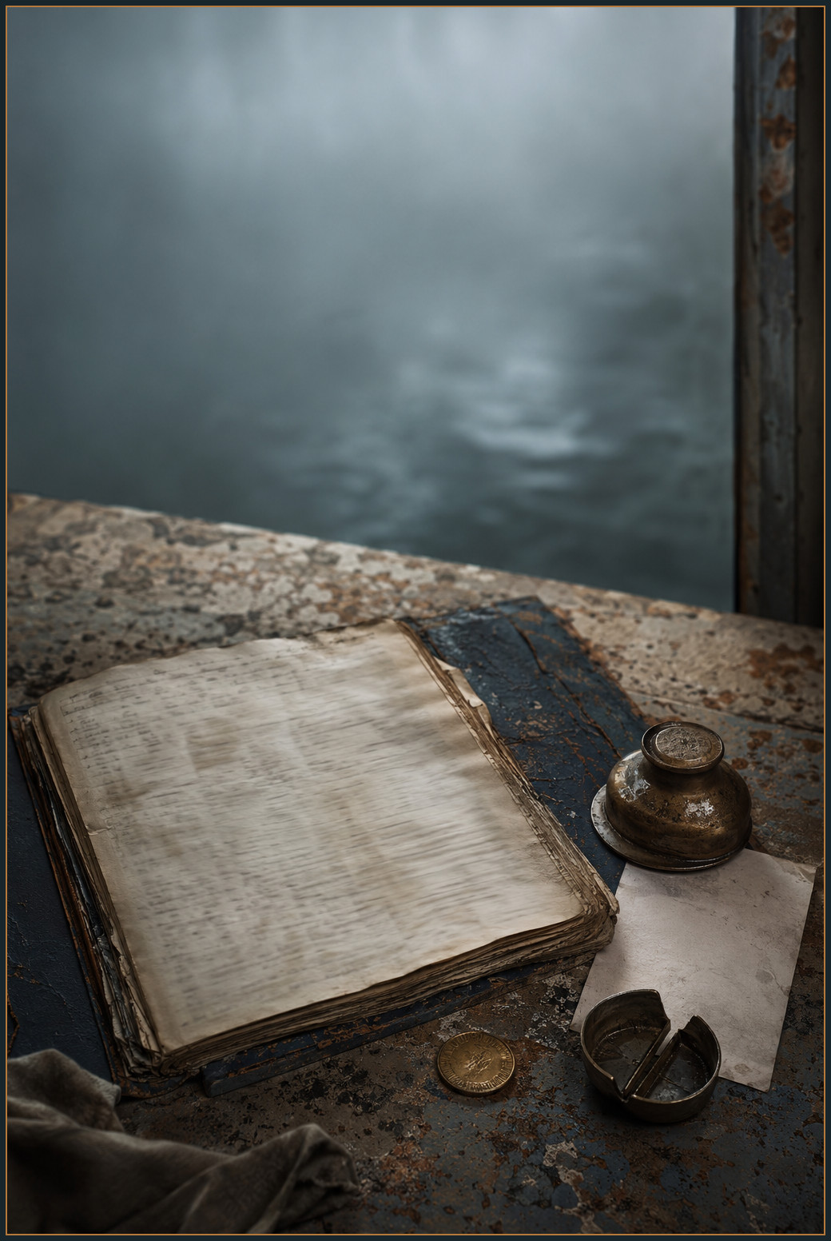
Record catalogued: NO-NNO-07-002.
WARD 7 DISTRIBUTION CENTER. Day 1, Year 19, dawn to mid-morning.
The registry gave Solène thirty-one children. The yard gave her forty-seven.
She counted twice, entered forty-seven in the margin, and weighed the first grain sack. It came up three pounds short. The second did the same. Oil ran nine percent low for the third distribution in a row. The east-pump failure had already become missed laundry wages, thin soup, and a clinic runner sent home with a permit number.
Cora called the diversion protection. Solène called it food taken from children. Neither claim erased the other. Solène wrote both beside Yvonne’s hidden receipt.
A girl named Junie arrived with a dead household address on her tablet. Solène entered her below the printed total. A Union truck followed. Its passenger brought one message: Sector Four was collecting people again.
The yard count rose to forty-eight: thirty-one names on the registry and seventeen children outside it. Solène kept both figures visible.
Solène opened a new ledger column and wrote UNRECONCILED COUNT.
The line began moving before she could decide what the new column meant. A grandmother from C-Block placed two dented tabs on the counter and asked whether the oil measure covered a child who had joined her household after the canal stairs collapsed. Behind her, a man in a laundry apron said his building had received no wash allocation since the east pump went down. He had spent the morning hauling water from a neighbor’s barrel and had already lost the day’s hotel contract.
Solène took neither complaint as proof of the truck. She gave the grandmother the last of the open oil jug, wrote the child’s description beside Junie’s name, and asked the laundry man which tap had run grit. Specifics gave a complaint somewhere to go. The distribution center had a wall map with colored pins, but Cora had locked the supply ledger in the office, and the map recorded pipes rather than the people carrying buckets up stairs.
“You are making a second registry,” Cora said from the window.
“I am recording the people present.”
“The Board will treat it as a claim.”
“It is a claim.”
Cora looked over the yard. She had changed out of the gray office coat and still wore its damp mark at the throat. The jacket made her look like someone who had planned to stay in the administration long enough to change it from within. Solène knew that posture. It had its own hunger.
“If you hand that to a patrol,” Cora said, “they will find the households before they find the oil.”
Solène shut the public ledger and pulled a scrap of packing paper toward her. She copied the names without addresses, then tore the sheet in half. One half went to Yvonne’s receipt. The other went in the stove ash tin.
“Then we keep two records,” she said. “One for feeding people. One for proving someone fed them.”
Junie stayed at the gate, her eyes on the scale instead of the grain. She set the brass measure on the floor.
“Can you read the big marks?”
Junie nodded once.
“Tell me when the needle reaches five. You don’t have to give anyone your tablet.”
The child crouched beside the scale. Her finger hovered a finger-width from the glass. When the next sack came up short, Junie said, “Four and a half.”
Solène wrote it down. Cora let her write. Outside, the Union truck had gone, but the dust it left still lay in the curb channel. The distribution yard kept working because the queue had nowhere else to go that morning in rain.
By mid-morning the paper forms had begun to soften. Children used their sleeves to keep rain from the ink. A father with two ration cards pressed one card flat against the counter while his daughter held the other under her shirt. The cards carried the same household number and different names. The Board had printed the first after the family moved floors and the second after a clerk decided the move was a new household. Solène asked which address they wanted visible. The father chose the old one for the ration line and the new one for the clinic runner. She wrote both on separate slips and kept the family number off the public copy.
Cora watched from the office doorway. The administrator had a stamp, a cracked tablet, and the power to close the intake window. She used none of them. A woman in a wet work coat asked for an oil measure for a child whose name had not made the registry. Cora checked the manifest, saw the shortage, and reached for the small jug beneath the counter.
Solène caught her wrist.
“If you give from that jug, record the measure.”
“The measure is already short.”
“Then the record needs the short measure.”
Cora poured. The woman held the cup under the stream. Her child waited behind her with both hands inside a torn coat. Cora wrote the amount and the child’s description on the packing paper, then asked whether the family wanted the description attached to the public count. The woman shook her head. Cora moved the description to the private slip. The choice cost the ward a name it could have used to make the shortage look precise. It left the family a little less exposed.
At the end of the queue, two parents argued in whispers over a wet form. Their son had been assigned to a school shelter three wards away. Their daughter had been left at a laundry room with an aunt who could not cross the Sector Four checkpoint. The Board’s form offered one guardian line. The mother asked Solène whether she could write two names.
“Write the person who can reach the child today,” Solène said. “Keep the other name in the household copy.”
The father looked at the public ledger. “Then they will say she has one guardian.”
“They may say it. Your copy will say what happened.”
He folded the second name into the hem of his sleeve. Solène did not ask him to surrender it for the record. She gave him the route to the shelter and marked the laundry room as a place to check after the afternoon tide.
The yard’s scale jammed when a child dropped a brass token into the tray. Junie crouched to retrieve it. The token belonged to a woman who had already left the line. Solène asked Junie whether she wanted to hand it to the clerk or keep it visible on the counter. Junie placed it beside the red pencil.
“Someone comes back,” she said.
“Then the token stays where they can find it.”
The small decision changed the clerk’s rhythm. Each time a person left the line to find a missing paper, Solène placed the paper and token together in a shallow tray instead of making the person start again. The line slowed at first. People stopped hiding wet forms under their clothes. A grandmother who had lost her household number in the rain came back with the number legible enough for Cora to verify. The yard had gained a procedure no notice had authorized.
At noon, a Board courier asked for the private count. Solène closed the packing-paper ledger and offered the public figure only. The courier said the Board needed to know which families were taking more than their share. Solène pointed to the scale receipts, the marked oil jug, and the seventeen children who had no allocation.
“You have the shortage,” she said. “You do not have permission to turn a child into a route.”
The courier wrote her name on his pad. Cora saw the entry and did not erase it. She moved the private slips into the flour tin after he left. Solène took responsibility for the refusal. Cora took the responsibility for the oil. Junie took the brass token to the woman who returned at dusk.
The yard emptied by degrees. A woman who had waited for a household number stood beside the closed scale and watched the last sack go into the storeroom. Solène found a dry corner on the packing table and spread the three records she had made during the morning. The public ledger showed thirty-one registered children. The margin showed forty-eight present. The private sheet held the seventeen descriptions without addresses. A fourth slip carried the laundry man’s report of grit at the east tap.
Cora brought the office key and set it on the paper. “The clerk who approved the last oil transfer will be at the south depot this afternoon.”
“You know that because the Board told you?”
“I know it because the depot is where they send a person they want to question without calling it a question.”
Solène did not ask Cora to go. She asked what the depot could prove. Cora named a loading time, a signature block, and a route code that appeared on both the missing oil manifest and the family’s wet receipt. The details could be checked. The intention behind them could not.
They carried the public ledger to the Anvil in a covered handcart. Junie walked beside it with the brass token in her palm. At the corner, a patrolman asked what the cart held. Solène opened the top slat and showed him empty sacks. Cora kept the private sheet under her coat. The patrolman touched the canvas and let them pass when the church bell marked noon.
The Anvil kitchen had already taken in two children from the queue. Yvonne moved the bowls to make room, then asked Solène to read the number aloud. Solène gave the registered count first, the present count second, and the seventeen unregistered descriptions only to the people who needed them for the afternoon route. The order mattered. It let the household act without making the private sheet a public map.
Junie set the brass token beside the scale. The woman who owned it had followed the handcart. She showed Solène a card with a different household number and said the card belonged to the floor below her own. The Board’s copy would send the oil to the wrong stair. Solène asked which stair had a dry landing. The woman pointed to a mark in the margin.
“Write the mark, not the address,” she said.
Solène did. Cora watched the change enter the ledger and then opened the office key in her hand.
“I can return to the depot,” she said. “If I take the route alone, the clerk may speak. If I take a witness, the clerk may close the door.”
“Go with a receipt runner,” Solène said. “The runner carries the time. You carry your own name.”
Cora looked at Junie. “And who carries the family number?”
“The family does,” Solène answered. “We carry the correction.”
The afternoon work split again. Cora left for the depot with the receipt runner. Junie stayed beside Yvonne to copy the marks that people chose to make public. Solène entered the east tap complaint on a separate route sheet and asked Lena to check whether the grit had reached the Thorn. The distribution center had closed its doors. The shortage remained after the doors closed.
Cora reached the south depot before the clerk could leave. The loading bay smelled of wet oil and cardboard. She showed the receipt runner the public route number and kept the private sheet folded in her sleeve. The clerk who had approved the transfer saw her and called for a supervisor.
“You came for a correction,” he said.
“I came for the time the truck left and the number on the seal.”
The clerk pointed to the manifest. It listed one oil measure for the distribution center and a second measure for a service lane. The service lane had no household name. Cora asked who had signed the second line. The clerk said the signature belonged to a contractor who no longer used the depot.
The runner wrote the time. Cora copied the seal number and asked the clerk whether the manifest could be photographed. He refused. She wrote image refused beside the number and left the original on the counter. The supervisor asked whether she wanted to file a complaint. Cora said the receipt already was one.
The depot’s scale leaned toward the wall. The runner placed a stone under one leg and checked the sack again. The measure changed by two ounces. Cora added the correction to the route sheet and asked the clerk to initial it. He did so after the supervisor watched him.
On the way back, the runner asked why Cora had not taken the manifest. She said a page taken without a receipt became a story about theft. A page left in place with a written refusal could travel farther. The runner kept the seal number and returned to the yard before the afternoon line closed.
Solène matched the depot’s time to the dock copy. The numbers agreed within three minutes. The service lane still had no household name and no verified reason for the diversion. She wrote both limits beside the short oil measure. The record gained a route and kept the question open.
The question reached the yard again before Solène could close the packing table. The courier returned with a red strip of paper and asked for the seventeen descriptions. He had replaced his wet coat with a Board jacket. The jacket carried a dry seal and a pocket that closed with a metal snap.
“The first request was for the count,” Solène said.
“The count changed.”
“So did the shortage.”
He placed the strip beside the scale. It named an emergency review and gave no appeal time. Cora read the line from the office doorway. The receipt runner stood behind her with the depot copy folded into his sleeve.
“If we send the descriptions,” Cora said, “the Board will call the list a security measure.”
“If we do not,” the courier said, “they will call it obstruction.”
Solène turned the strip over. The paper had been cut from a larger form. A partial serial remained at the edge. She copied the serial, then asked the courier whether the original order was available. He said it was at the central office. She wrote request seen, source not supplied and returned the strip.
“You can carry the descriptions when you carry the order,” she said.
The courier’s face tightened. “The children are not yours.”
“Neither is the shortage.”
He took the strip and left. Cora watched him cross the yard. The Board jacket made a bright line in the rain. Junie held the brass token against her palm and asked whether the courier would come back with the order.
“Maybe,” Cora said.
“What do we do until then?”
Solène pointed to the scale. “We keep the number where people can check it.”
A line worker approached with a torn glove and a request for a break. The distribution center had added two sacks to the afternoon load without adding a person. She had been lifting with her left hand since the east tap complaint began. Solène asked what she could carry without pain. The worker said one half sack and a tally board. Cora checked the pay sheet and found no code for a half shift.
“Write the half shift,” Solène said.
“The Board will refuse it,” Cora said.
“Then the refusal has a place to land.”
The worker took the tally board. She did not accept a replacement hand until she had written the first measure herself. The line slowed. A father who had arrived for a clinic route held the sack while she rested. His daughter held the card. The household names stayed off the public sheet, but the labor did not disappear.
When the depot runner left, he handed Cora the stone used to level the scale. He had marked one face with the loading time. The mark would fade in rain. Cora wrapped the stone in the depot copy and asked Solène to place it with the kitchen’s route weights. The evidence now had a physical witness that a person could hold, alongside a number that a clerk could revise.
At dusk, the grandmother from C-Block returned with the child she had added to her household. The child carried an empty cup. Solène measured the remaining oil and showed the grandmother the line where the measure ended. The woman chose to take half and leave half for a neighbor with a fever. Solène recorded the split on the private copy and asked whether the public count should show two recipients. The grandmother said yes, but not the floor number.
Cora made the second entry. The Board’s total did not change. The yard’s knowledge did. Junie put the brass token back in the shallow tray. Someone would return for it. The line had learned to leave a place for a correction without asking a child to carry the proof.
The courier came back after dark with the original order folded into a plastic sleeve. The seventeen descriptions had been reduced to eleven because six families had refused a public line. He set the order on the table and asked Solène to sign that the descriptions were incomplete.
Solène read the revised count and asked who had removed the six. The courier said the central office had done it. Cora copied the sleeve number and wrote source named, editor absent. The courier wanted the private sheet. Solène offered the public count, the refusal number, and the signed scale receipts.
“A count without the choices is not the same count,” she said.
The courier took the public copy. He refused to sign for it. Junie held the brass token beside the receipt and asked whether a refusal needed a witness. Cora answered yes. Junie wrote her worker number on the margin and left her household blank. The Board received a copy and a record that its receipt had been declined.
The father whose daughter had been assigned to the distant shelter returned with the second guardian name sewn into his sleeve. The shelter had asked for a single name again. Solène offered the public guardian line and a private household line. The father chose both and asked that the shelter’s wrong floor be corrected. Cora added the floor error to the route card.
At closing, the distribution yard had thirty-one registered children, forty-eight present, eleven descriptions released, and six refusals. Solène wrote each number on its own line. The line held because the yard had stopped asking one total to carry every fact.

End of reader sample. Continue with Chapter 2, “The Anchor Drags,” in the full First Edition.

